Assignment 4.2: Post-internship Critical Reflection

|  |  |
| --- | --- |
| Name: | S M Ragib Rezwan |
| Student number: | 103172423 |

**1. Linking your internship experience to university/disciplinary learning**

In my university, I am studying under the cyber security discipline. This is basically the specialization that introduces students to various theories and tools that are used to defend computers, servers, mobiles devices, electronic systems, networks, and data from malicious attacks **(Kaspersky, 2020)**. Hence, before going into the internship, I already had good theoretical knowledge regarding various attack methods (like DDOS attacks, malware, etc.) alongside tools that can be used to perform and mitigate them.

So, in my first few weeks, I had utilized those tools (alongside documentation and CVE reports) in order to develop a simple Risk matrix table **(Figure 1)** for the all the software (Zoho, Wordpress, SMS-magic, etc.) that was being used in my company, 99aupairs. This not only helped me to categorise and prioritise the current threats, but also enabled me to explain them in a simple, clear-cut manner to my supervisor, Irene. This enabled her to fully comprehend the current situation of all the software and thus permit me to take action.

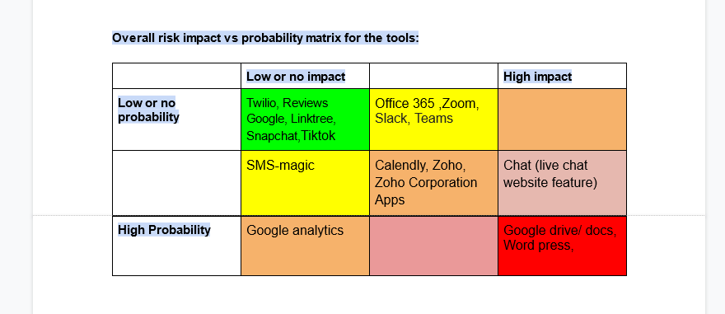

**Figure1: Simple Risk Matrix table**

For instance, one of the worst vulnerability that had been detected was that the old website on Wordpress had not been protected against XSS, enabling me to easily find the tables used to store data from the website **(Figure 2)**. This was because during development, the web developer had mixed up various hard-coding and dynamic-coding techniques, creating a convoluted website where the codes ended up tripping over one another. So, by showing how easy it had been for me to “hack the website”, alongside showing the mess it actually was, I was able to convince Irene to approve the creation of a new website from scratch instead, using proper security features (like OTP, Captcha, etc.)

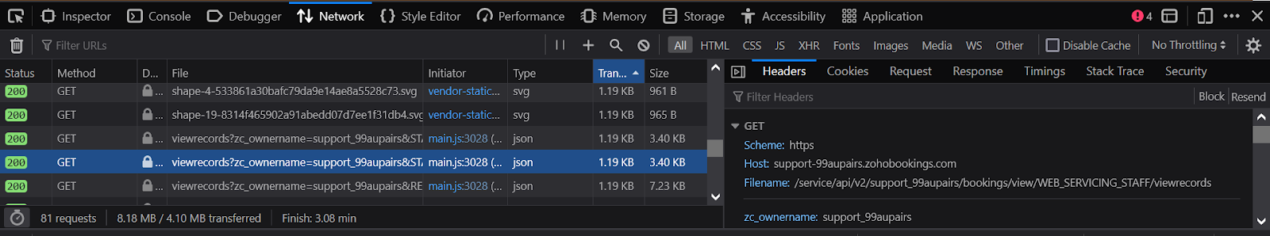

**Figure 2: One of the table that could be seen**

*[Note: all the table names and their locations were altered soon after for security]*

Furthermore, throughout my internship, I was also able to notice various poor security practises that were used by the company and rectify them (by explaining and advising relevant individuals). One of these had been access control in Google document. Previously, the company had been allowing anyone who knew the link to access the document, instead of restricting it to only people who need to have access (i.e. the Principle of Least Privilege from **Wikipedia** **(2022)**). Although this had been done for convenience, it was an extremely bad practise as it could allow anyone who knew the link to access and modify the content in there. Luckily, I had noticed about the matter before anything took place and pointed it out to Irene, who immediately followed my advice and rectified it.

But, that doesn’t mean that I was able to resolve all the issues in the company during my internship. Instead there were few cases where even though I knew the solution, I couldn’t implement it due to high financial and convenience issues in the company. This made me realise that in industry, although most problems have easy solutions, they are still not implemented due to restrictions in resources. Thus, I was able to come into terms with the fact that in my future career, there will be various scenarios where I wouldn’t be able to properly resolve an issue, not because of lack of knowledge, but due to lack of budget.

**2. Development of professional/workplace capabilities**

Among the different skills noted, I believe I have developed my communication skills the most. Before this internship experience, I had been extremely introverted, doing almost everything possible in order to avoid communicating with people. That’s because I used to be scared of what they would think of me and whether they would even listen to me.

But luckily during my internship, I was able to find an opportunity to overcome that, albeit by a slight step. That’s because during that time, Irene had to go abroad to give various talks about the company to the schools and organizations there. This had led her to not only become extremely busy, but also be on a different time zone, making it difficult for her to perform the daily check-in meetings with everyone. Thus, she delegated most of the intern meetings to me (on my internship days) and asked me to report back to her regarding any problems that might arise.

When I first heard about it, I felt extremely nervous and scared. After all, I rarely communicated with people I knew, let alone people I have never met before! But, even so, I knew I couldn’t say no. That’s because in cyber security career, alongside technical skills, one must also be able to effectively communicate with employees and business stakeholders at all levels **(Ramses, 2016)**. Furthermore, it was also a request from Irene and I didn’t want to let her down.

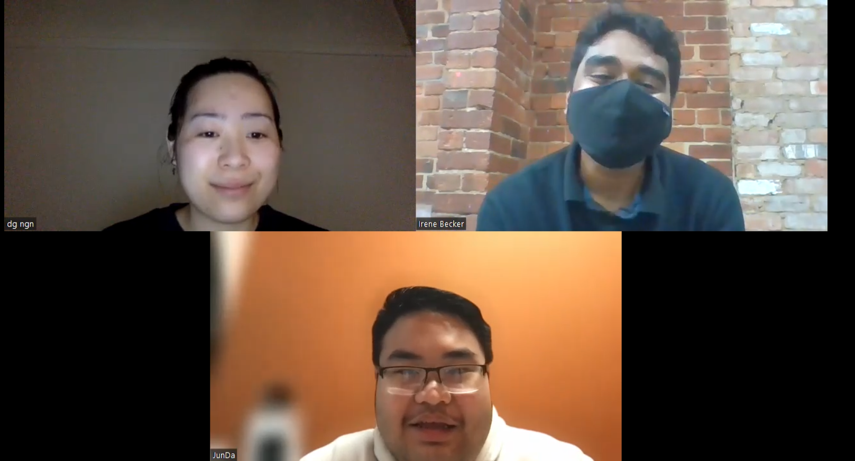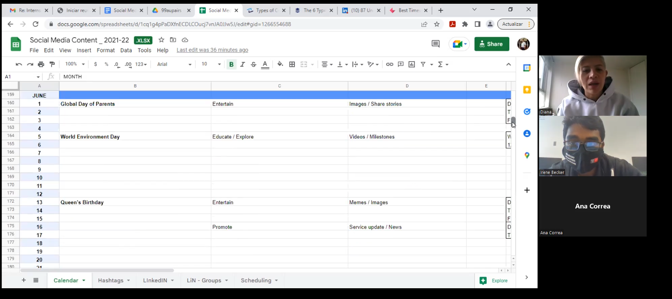So I geared myself up and went for it, preparing for the worst case scenario where people would ignore me. But the reality was extremely different! In all the meetings, everyone would arrive well before the selected time and were extremely engaging **(Figure 3, 4)**. Thus, I was not only able to note down their issues and concerns, but was also able to have a fun and relaxing time chatting with them!

**Figure 3, 4: Chairmaning Zoom meetings using Irene’s Zoom account**

Later on, during my feedback meetings with Irene, she revealed to me that everyone had been extremely impressed with the way I had taken the meetings. Thus she wanted me to chairman the meetings more often, even noted it as a “hidden talent” of mine.

This not only helped me develop my confidence, but also helped me come out of my shell and interacting with the people, with my own initiative. Although, I can’t say that I have overcome all of my fears regarding communication, I can say that I have taken at least one step in overcoming it, through my internship experience.

**3. Ethical, sustainable, and inclusive practices**

Ethics are basically sets of rules to determine how people should behave, made using accepted beliefs on right and wrong **(Swinburne Career Center, 2021)**. Thus, it is commonly used in business practices in order to ensure that the decisions that are made are fair (and hence build trust among their employees, customers, etc.). Although I noticed various situations in the industry where ethics had come into play, the one that stood out to me most was the decision on use OTP and Captcha on creation of emailing list for the company.

Basically, in the 99aupairs website, there were several forms that were used to segment customers into various groups (like Subscribers, Aupairs, Host family, etc.) in order to ensure they receive the specific news that they desire. Unfortunately, this was also where Spammers would pass bogus information (or even malicious codes).

Now, the best method to resolve it is to use a combination of Captcha and OTP to secure the forms. That’s because Captcha ensures that an actual person is entering the information while OTP ensures that that email being entered is valid. Thus, it fully protects the form from scammers.

But, in order to complete OTP, customers need to have their email open where they would receive the OTP. This, in turn, would be an inconvenience to the customer (as too many steps) and would make them reluctant to proceed (especially for ones who are still just browsing and not sure what to do).

So, it basically was similar to the bicycle scenario from tutorial 3 **(Dr Vida V. & Dr. Nicole F., 2022)** where the person had been confused on whether to prioritise customer’s safety or their desire.

In the end, I discussed the matter with Irene, who advised me to perform a compromise:

|  |  |  |
| --- | --- | --- |
| Form Purpose | Security setup | Rationale |
| Add people to subscriber list only | Captcha only | They will only browse through the website and are still not sure whether to take part or not |
| Add people to Aupair or Host family list | Both Captcha and OTP | The company would contact them at regular basis for feedback |

This helped me realise that even though it wasn’t the best practice according to security, in order to fulfil customer’s wishes and expectations, we sometimes need to compromise on security aspects. But even so, we still need to keep the bare minimum and not forgo that, no matter what (i.e. using Capta to prevent bot attacks).

**4. The future**

Overall, through this internship, I ended up developing my soft skills, rather than any gaining technical knowledge. Furthermore, although I did experience how various cyber security theories and concepts are utilized in industry, these were focused on website protection aspects only (like DDOS attacks mitigation, SQLI attack mitigation, etc.). Thus, currently, I plan on taking part in more internships and placement opportunities in other companies, in order to further enhance my skills (and also gain experience) in other areas of my discipline (like infrastructure, cloud, IOT, etc.). I believe that will help me further build up on the crucial skills necessary for my career in cyber security.

**5. References**

1. Kaspersky, 2020, *What is Cyber Security?,* Kaspersky, viewed 30th Oct 2022, <https://www.kaspersky.com.au/resource-center/definitions/what-is-cyber-security> .
2. Wikipedia, 2022, *Principle of least privilege*, Wikipedia, viewed 30th Oct 2022, <https://en.wikipedia.org/wiki/Principle_of_least_privilege> .
3. Ramses, G. 2022, *Security Think Tank: Communication is key to cyber security in digital era*, ComputerWeekly.com, viewed 30th Oct 2022, <https://www.computerweekly.com/opinion/Security-Think-Tank-Communication-is-key-to-cyber-security-in-digital-era> .
4. Swinburne Career Center, 2021, *What is ethical decision making?*, Swinburne Career Center, viewed 30th Oct 2022, <https://swinburne.careercentre.me/resources/newsroom/newsroom.aspx?NewsID=17052> .